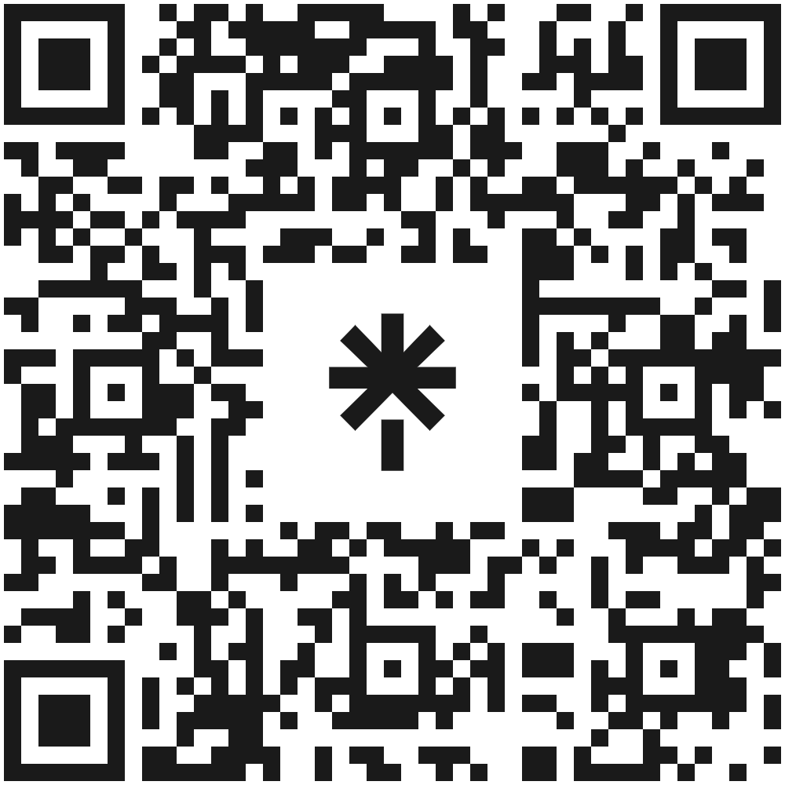

New Transfer Student Resources: Summer 2023

General Transfer Resources
Office of Transfer Student Success (https://transfer.utah.edu/)
- The mission of the Office of Transfer Student Success is to improve equitable transfer student experiences and outcomes by providing leadership for and supporting coordination of transfer activities and functions across campus.
- New Transfer Student Welcome: Tuesday, August 29th, 2023 from 11am-1pm outside of Sill Center
- National Transfer Student Week: October 16-20th
- Transfer Workshop Series Info & RSVP: https://transfer.utah.edu/transfer-workshop-series.php
- Instagram: https://www.instagram.com/uofu_transferstudentsuccess/
- Eats with Emily (talk with a current transfer student): every Thursday from 3:30-4:30pm in Sill Center room 144 until August 17, 2023 (except 6/1/23)
- Herriman Campus: https://herriman.utah.edu/

Center for Equity & Student Belonging (CESB) Transfer Scholars Program (https://diversity.utah.edu/cesb/transfer/)
- The Transfer Scholars Program creates community and advocates for students across intersectional identities and experiences by promoting academic excellence, extracurricular involvement, and graduate school exploration.
- Instagram: https://www.instagram.com/uofucesbtransferscholars/

ULife Mentors for Transfer Students (https://mentors.utah.edu/)
- Mentors help you adjust to life at the University of Utah and provide social, academic, and professional programs and workshops.

AAC Credit Transfer Resources (https://advising.utah.edu/transfer/transfer-your-credits/index.php)
- Learn about transferring your credits and how to get advice on transfer credits counting towards your degree.

Transfer Student Groups
Crimson Transfer Honor Society (CTHS) (https://transfer.utah.edu/crimson-transfer-honor-society.php)
- CTHS’ mission is:
  - to recognize the academic success of transfer students as they transition to the U of U
  - to encourage and support transfer students as they matriculate to graduate schools and begin careers
  - to get transfer students involved in the University of Utah campus and to serve the community
  - to aid transfer students socially, academically, and financially
- Eligibility is at least a 3.5 GPA in your first 12 credit hours at the U of U and attendance at two transfer workshops (in-person or virtually)
- Instagram: https://www.instagram.com/uofu_cths/

Business Transfer Student Society (https://eccles.qualtrics.com/jfe/form/SV_6LItaFsmahdhzkW)
- An opportunity for business majors to find friends, participate in workshops, socialize, and engage in service projects.

Transfer Student Cohort Courses and Academic Programs
Business Scholars Transfer Program (Eccles.link/transfer)
- Unique one-semester cohort program designed for students with college experience. It combines experiential learning and traditional teaching methods in the classroom with opportunities for personal and professional development.
- Meet with the Business Student Council Transfer Student Representative: https://www.linkedin.com/in/dawson-ber2z/

College of Science, Science Research Initiative (SRI) (science.utah.edu/sri)
- The (SRI) program offers College of Science students the opportunity to participate in discovery-based scientific research starting your first day on campus, with no prior research experience required. The SRI will jumpstart your path of academic success, and give you needed skills to prepare for an internship or a career - whether that's in a research lab, an office, or one of the many other opportunities open to our graduates.
Department of Writing & Rhetoric Studies (https://writing.utah.edu/undergraduate/transferstudents.php)
- No matter what your major or career goals, writing will be important to your success. The Department of Writing & Rhetoric Studies (WRS) is here to help you become an effective and flexible writer in your U classes and beyond.
- Write4U (Writing 3020): For students in all majors, fulfills upper division Communication & Writing (CW) and Humanities Exploration (HF) requirements.
- Writing Studies Scholars: For students in Writing and Rhetoric Studies, $2,000 scholarship, tuition-free bridge course, optional tuition-free study groups, paid professional development opportunities.

Discover U (UGS 2500) (https://discoveru.utah.edu/)
- Discover U is a learning community for transfer students and sophomore students focusing on wellness, making connections, finding resources, and major exploration. It combines the personal attention of a small college experience with the unparalleled resources of a large research university.
- $1,000 scholarship for students who complete the course, 1 credit hour course

Honors College
- Earn an Honors degree, gain research experience in your field, and be a part of the Honors Transfer Student Learning Community.
- Honors College students also have additional scholarship and leadership opportunities available to them.
- Incoming transfer students can apply through the U of U Undergraduate Admissions Application or current students can find a current student application https://www.honors.utah.edu/admissions/current-students/

Politics of Borders and Migration (Ethnic Studies 3790) (https://migrants.lib.utah.edu/)
- This course was designed to support and help transfer students acclimate to the University of Utah
- For students in all majors, fulfills upper division International Requirement (IR), oral history project with community organizers in Greece

Last updated 5/23/23

